**Report**

MRF Image based Indoor Positioning Solution

MRF Geosystems Corp.

Table of Contents

1 Problem Definition and Objectives 1

2 System Architecture 2

3 Image based localization algorithm 4

3.1 Local feature descriptor 4

3.2 Image matching using descriptors 4

3.3 Position Estimation 4

4 Challenges and Discussions 5

4.1 Image Preprocessing for Matching 5

4.2 Descriptor Algorithms 5

4.3 Distance measurement for image matching 5

# Problem Definition and Objectives

Location-based services have been drawing a lot of attention from industry and research. One of the key enablers of location-based services was the adoption of the easy-to-use and accurate GPS positioning technology. GPS was well known to support outdoor positioning, but it is inadequate to track people in indoor environments with high precision. The reason lies in that the GPS signals cannot be well received in the indoor environment - the multipath effect severely limits the precision of location estimation.

In the recent decade, many indoor positioning technologies have been studied and applications been implemented. The typical ones include ultra-wide band, WLAN and Bluetooth. These technologies have their own strengths and limits. For instance, ultra-wide band can provide a high precision of positioning, however its navigable space is usually limited to a small area due to the expensive infrastructure. WLAN and Bluetooth can use existing infrastructure thus minimizing the cost, but their precision can be limited.

MRF’s image-based indoor positioning solution aims to achieve two important objectives at the same time: minimizing the implementation cost while providing an acceptable precision. The image-based indoor positioning can greatly reduce the implementation cost because it does not rely on hardware infrastructure and only requires mobile cameras.

# Process of MRF’s image-based indoor positioning

MRF’s image-based indoor positioning involves four key components - image database, image processing, image matching, and position estimation (Figure 2-1).

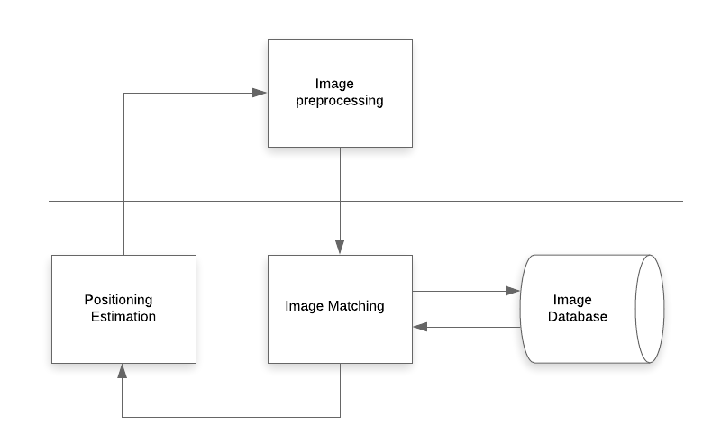

Figure 2‑1: System Architecture

Image database: Image database is a storage to keep the reference images and their location information. The location information can be in numeric format such as coordinates or descriptive format such as floor 2.

Image matching: Given a query image, image matching refers to the process to find its best-matched reference image from the image database.

Positioning estimation: Once the best-matched image is found, its location information can be used to estimate the position where the query image is taken. The simplest way for estimating the position can be directly taking the location of the reference image as that of the query image.

Image processing: Image matching is based on the intensity information on pixels. Image processing is significant for image matching as it helps to remove noise information from the query image and produce better quality image for image matching.

# Image matching

## Local feature descriptor

Local feature descriptor is essential for image matching and should be invariant to affine transformations. Local feature descriptor is commonly generated in two steps: 1) selecting interest points, and 2) describing the interest points using neighboring information. Selecting interest points can be done by detecting local extrema (e.g. corners). Describing the interest point can use neighboring information such as the intensity or the orientation of the neighbors of the interest point.

Scale-Invariant Feature Transformation is among the mostly-used algorithms to generate local feature descriptor. Table 1 illustrates the procedure of the SIFT algorithm. Detailed information about the algorithm can be found in the Digital Image Processing textbook. From SIFT, many variants were developed such as PCA-SIFT and SURF. A performance comparison of these algorithms can be found in many literatures.

Table 1: Summary of the SIFT Algorithm

|  |
| --- |
| * + 1. Construct the scale space     2. Obtain the initial interest points     3. Improve the accuracy of the location of the interest points     4. Delete unsuitable interest points     5. Compute the orientation of the interest points     6. Generate the local feature descriptor of the interest points |

## Image matching using descriptors

Because the number of images in the database is usually large and at the same time quick response is critical in the same applications, efficient nearest-neighbor image matching is very important. Some well-known methods for image matching are BruteForce, Approximate Nearest Neighbors (ANN), and Locality-Sensitive Hashing (LSH). Experiments are required to compare the performance of these methods for an image matching task.

# Position Estimation

Because the location information have been already attached to images in the image database, the information of the best-match image can be used for estimating the position of the query image. However, due to the aforementioned uncertainties, mechanisms should be implemented to tune the estimation to improve the precision of positioning.

To address the uncertainty from perspectives, a confidence measure can be calculated. As we assume that users tend to take their focus of attention closer to the center of the image, the confidence is measured by the distance of matched points from the center of the query image.

$$C=\sum_{k=0}^{n}{e^{−(x^{2}+y^{2})/2σ^{2}}}$$

To address the uncertainty from scale, distance between the actual position and the estimated position should be calculated. As Figure 3-1 shows, the distance d can be estimated from a – the distance between matching points in the query image, b – the distance between matching points in the best-match image, and c – the camera field of view.

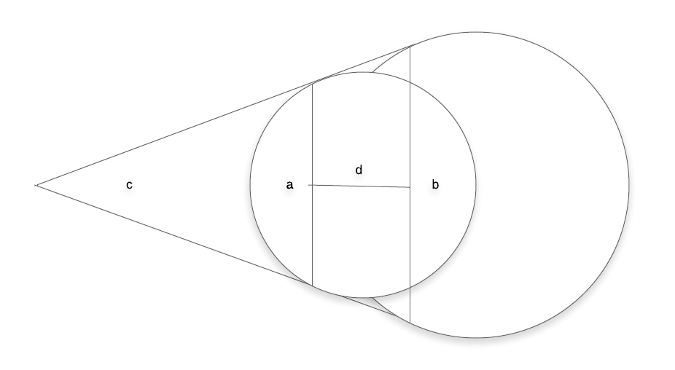

Figure 3‑1: Distance Estimation

# Experiment

## Hardware and software

The environment of experiment is a two floor residential house. Images for the experiment are collected using iPhone Max Xs. The specification of the phone camera can be read from its Exif meta-data. To be specific, the sensor size of the camera is 5.6 mm * 4.2 mm; the focal length is 4.25 mm. The sensor size and the focal length will be used to calculate the FOV of the camera. Considering the use of camera in the actual indoor positioning scenarios, the iPhone is vertically positioned while taking images.

Software used for the experiment are Visual Studio Code and Python. Visual Studio Code is a free and mature software development environment. Python is a mainstream programming language. In this project, Python version 2.7 is used. Some libraries are deployed to provide basic operational and mathematical functions, such as reading/writing files, and trigonometric calculations.

The operation systems for the experiment is macOS Catalina with processor 3.1 GHz 6-Core Intel i5 and graphics Radeon Pro 575X 4 GB.

## Design and result of three experiments

Three experiments are designed according to the discussions in the previous section.

The first experiment evaluates the the accuracy of image matching using the SIFT algorithm. The second experiment evaluates the method for position correction. The third experiment justifies the use of confidence measurement for image matching.

**Experiment 1 : accuracy of image matching using SIFT algorithm**

Design: Experiment 1 involves three steps: 1) images are collected in the experimental environment - residential house, as reference images, 2) An image database is created from the collected reference images, 3) an image matching program is written to find the best-matched image from the image database, 4) query images are randomly taken, and fed into the image matching program to find their matched reference images for position estimation.

Step 1: Given that the experiment is carried out in a residential house whose space is limited, 59 reference images are collected and assumed to be enough to meet the experiment needs - covering all the noticeable features in the house. The naming of the images are based on the main feature in the image e.g. hallway.

Step 2: From the reference images is created an image database. The image database stores key-points and descriptors of reference images. The key points and descriptors are essential for the image matching. The key point and descriptor information are generated using the SIFT algorithm described in the previous section.

It is worth noting that preparing the image database is a time-consuming tasks given that all the reference images have to be processed at pixel-level. The time required to prepare the image database can vary based on the computing capacity, volume of images and their resolution. In this experiment, preparing the image database takes approximate 2 minutes.

Step 3: After the image database is created, an image matching program is written to read a query image and make find their best-matched reference image from the image database. The image matching of the query images involves two steps. Firstly, descriptors of the query image are matched with descriptors of each reference image in the image database. Two commonly used algorithms for matching descriptors are BF (brute-force) and FLANN (Fast Library for Approximate Nearest Neighbors). A simple testing is made to compare their performance. Figure X shows the testing result of matching two hallway pictures using both BF and FLANN. Both algorithms find 53656 matched pairs between the two images. However, BF takes 30.54s while FLANN only takes 5.02s.

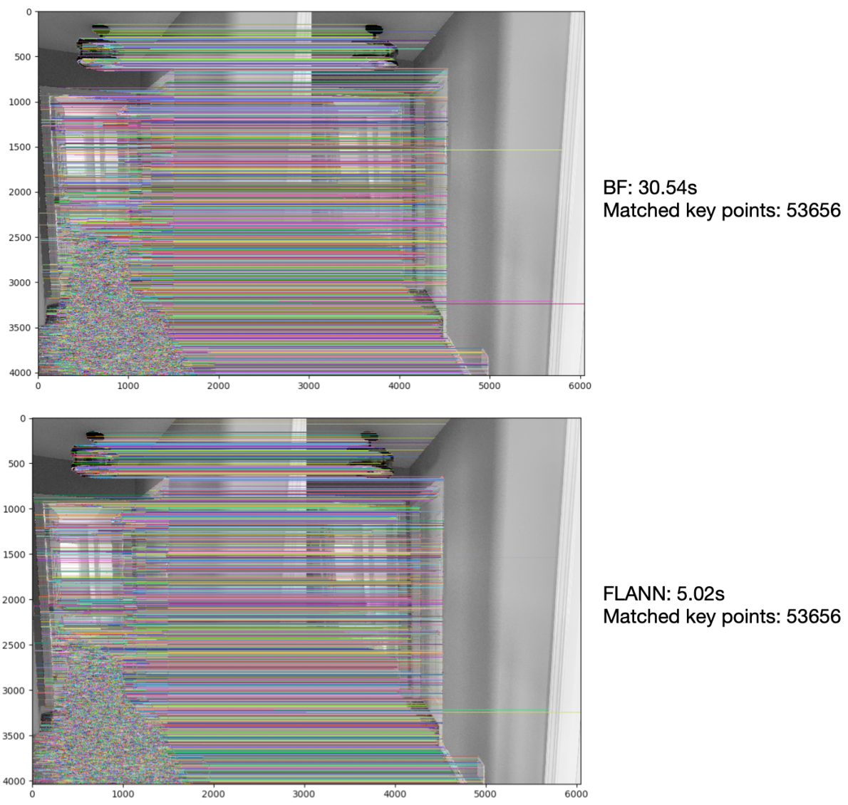

Figure 1: Comparison of BF and FLANN for image matching

Secondly, based on the number of matched key-points in the reference images, the best-matched image is determined. Figure X illustrates how the best-matched reference image is determined by the number of matched key-points. In the Figure, the query image is compared with two reference images from the image database. The matching result shows that 1073 good matched key points are found in the first reference image and 99 found in the second. Hence the first reference image is a better match than the second reference image. With the position where the first image is taken available, the position where the query image is taken can be estimated.

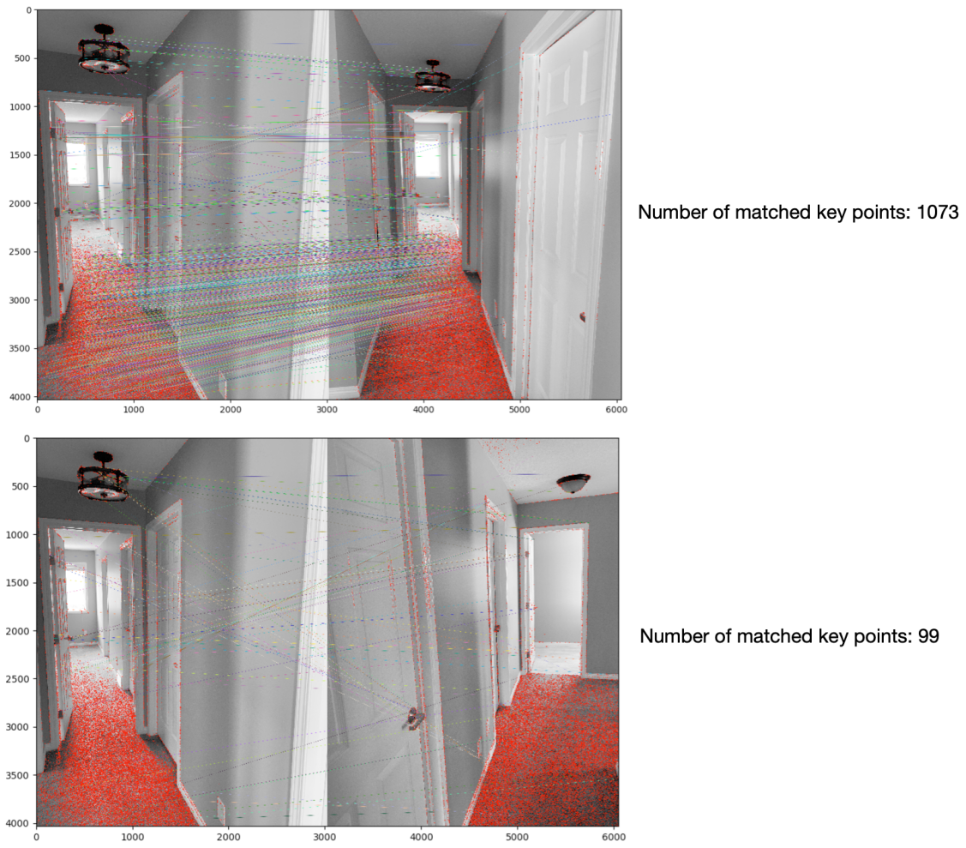

Figure 2: Selecting the better-matched image by the number of matched key points

Step 4: 8 query images are taken and fed into the image matching program respectively to find their best-matched reference images. The best-matched reference images have been marked for each query image before the running the program. The aim is to check 1) if the best-matched images can be matched with the query images, and 2) if the position where the best-matched reference image was taken can be used to estimate the position where the query image was taken.

Result: Figure 3 shows the result of image matching of the 8 query images. Except for the query image 6, other query images are successfully matched with the correct reference images. The reason of failed matching will be discussed in the later Discussion section.

On observing the matching result, when the query images are matched with correct reference images, its camera position can be reasonably assumed as that of the matched reference image. In this case, the deviation is no more than 2 meters.

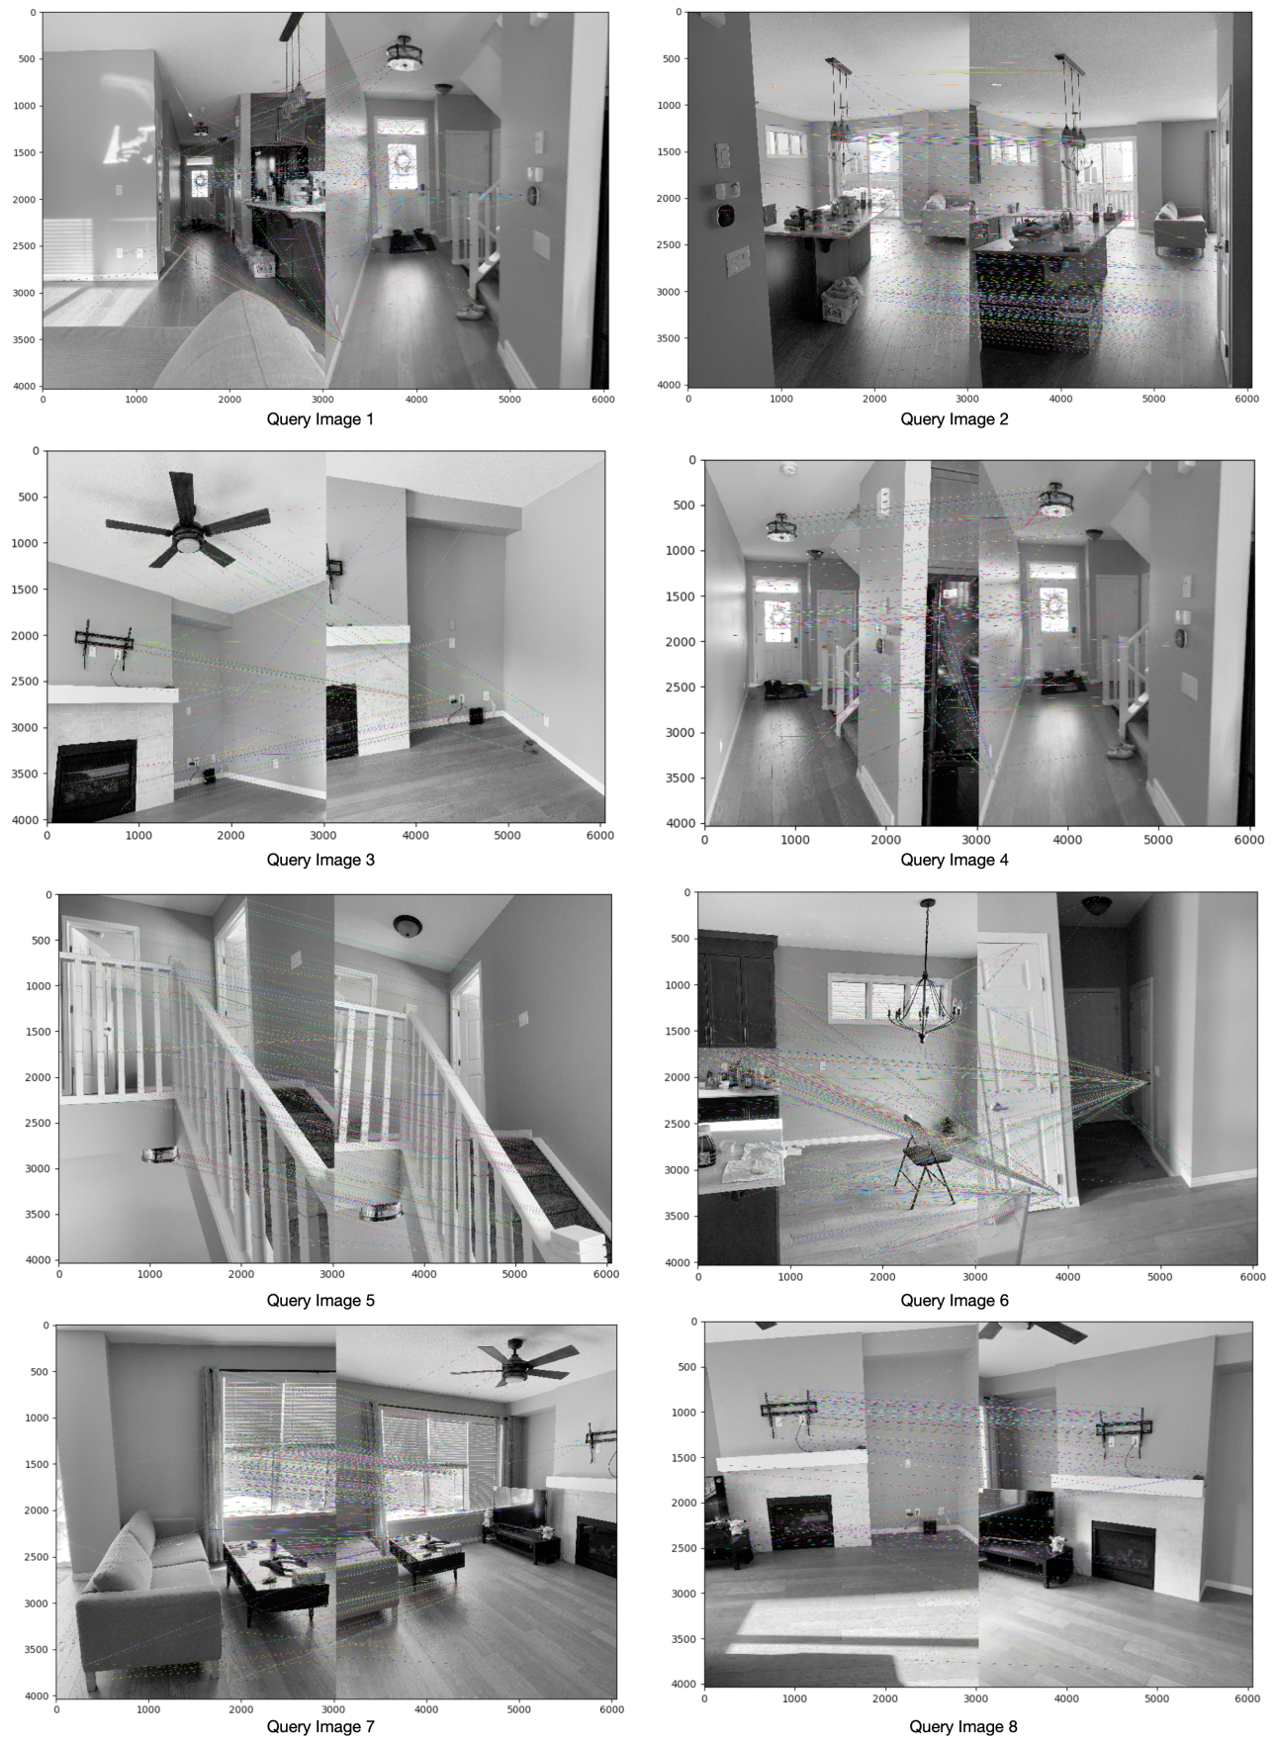

Figure 3: Best-matched reference image for each query image

**Experiment 2: positioning improvement with consideration of camera distance**

Design: Experiment 1 shows the adequate results of image matching and implies the appropriateness of using image matching for estimating indoor positions. But it is worth noting that estimating positions solely based on feature matching can be error-prone, if the camera distance is not considered. Experiment 2 aims to improve the estimation of indoor positioning by taking into the consideration of camera distance. The rationale is that the difference of the camera distances of the reference image and query image can be useful information to improve the accuracy of indoor positioning. This experiment involves two steps: 1) two images are taken for a same object and with different camera distances, and 2) the position correction schema is applied to calculate the difference of the camera distances of the reference image and query image.

Step1: Figure 4 shows two images captured with different camera distances. The left image is captured at a distance of ~0.3m and the right image is captured at a distance of ~0.6m. In this experiment, it is assumed that the left image is the reference image and the right image is the query image. The image matching between the two image is executed as indicated by the Figure.

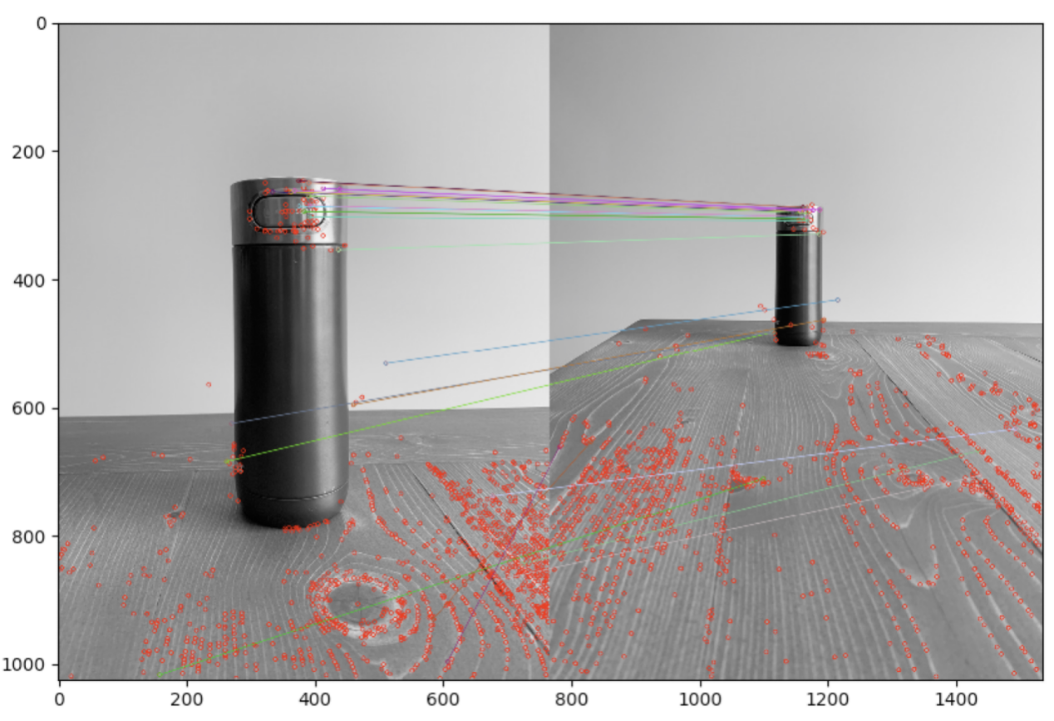

Figure 4: Bottle images taken with different camera distances

Step 2: A program is written to implement the position correction scheme. The aim is to calculate the ratio of two camera distances. The ratio of the two camera distances is proportional to the ratio of the bottle size in the two images, which can be estimated by the calculation of the respective ratio for each pair of matching points. For convenience, the equation of distance to object is put here.

$$Distance to object (mm)=\frac{f(mm) * real height (mm) * image height (pixels)}{object height (pixels) * sensor height (mm)}$$

Result: After the calculation, the ratio of the camera distances is obtained to be 1.98, which is close the the real distance ratio of the camera distances ~0.6m/~0.3m.

**Experiment 3: confidence of image matching**

Design: Users tend to focus the object of their interest in the middle of the screen while shooting images or videos. Therefore, an assumption can be made that the reference image is more likely to be the best-matched image if its matched key-points are closer to the center of the image. Here, the term “confidence” is used to denote how confidence the matched reference image is the best and measured by the closeness of matched key-points to the image center. To obtain and validate the confidence of image matching, this experiment involves two steps: 1) a set of images are taken as reference images, and 2) a query image is used to calculate the matching confidences of reference images.

Step 1: A set of sofa images are taken as reference images. To test the confidence, the sofa images are taken at different distances and from different angles.

Step 2: The query image is taken and matched with all the reference images to obtain the confidence value of each reference image.

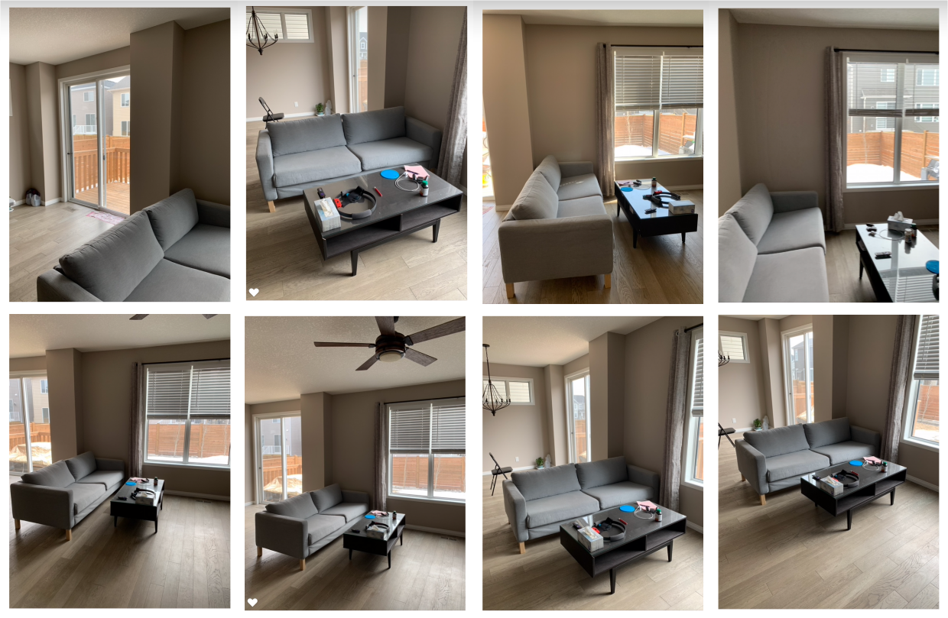

Figure 5: Seven reference images and the query image at the bottom-right corner

Result: Figure 6 shows the calculated confidences of three reference images. In the first pair of images, there are 1359 matched key points and the matching confidence is 4.187. In the second pair of images, there are 273 matched key points and the matching confidence is 1.655. In the last pair, there are 118 matched key points and the matching confidence is 0.004.

The result illustrates that the confidence can correctly reflect the extent to which the reference image is well matched with the query image - the first pair with the highest confidence value represents the best match, followed by the second one and then the last one. This result can be easily comprehended by observing the pairs of images. In the first pair of images, the two images are taken with similar camera angles and distances. In the last pair of images, a obvious angle different can be noticed and results in a less confidence value.

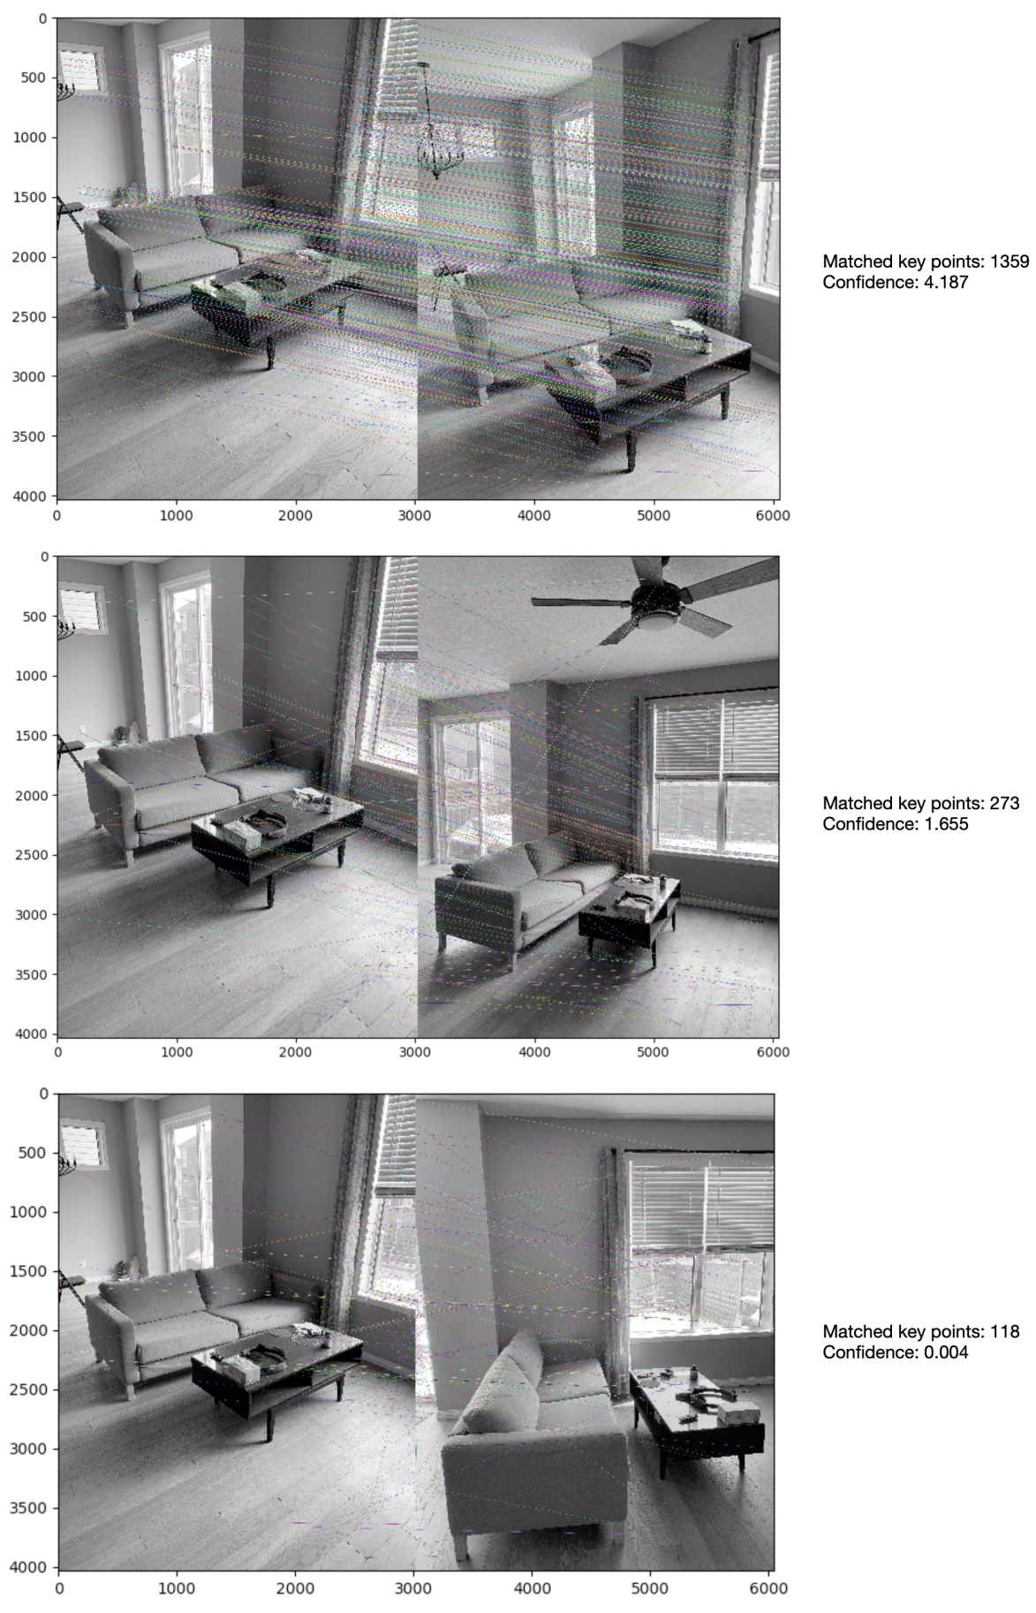

Figure 6: Confidence of reference images

During the experiment, it is found that confidence can be useful to reject the wrong best-referenced image. As indicated by Figure 7, the right image is found to be the best-matched image of the left image because it has the maximum number of matched key points. However, given that the confidence value is only 0.005, this matching should be rejected. In such cases, using the confidence in a combination with the number of matched key points can be a more effective indicator to determine the best-matched reference image.

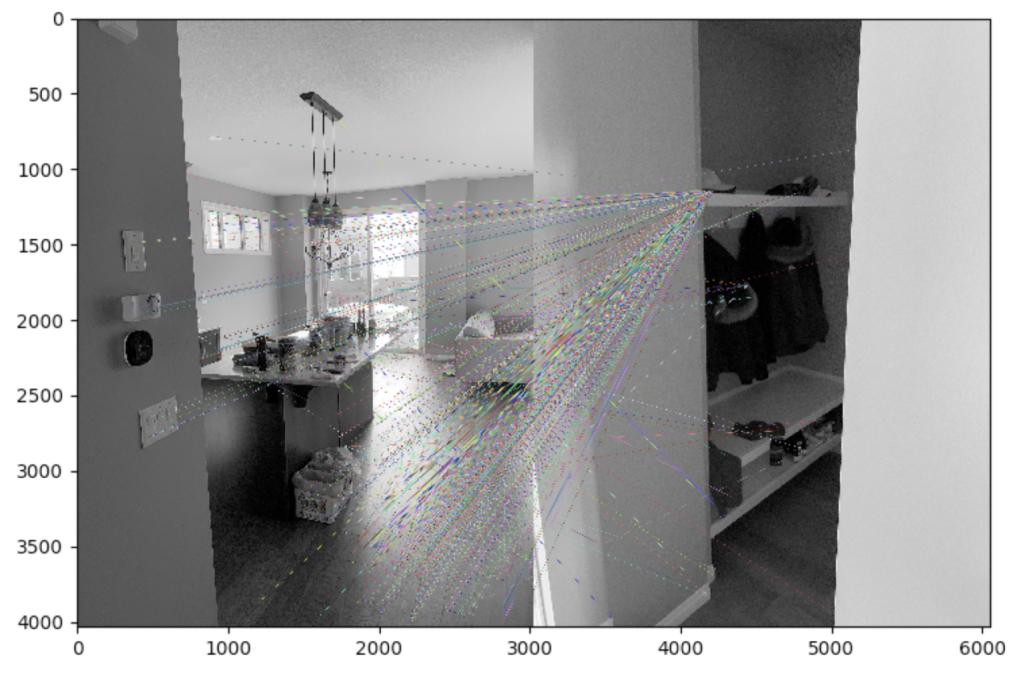

Figure 7: Wrong best-matched reference image

**Experiment: Discussions**

Firstly, adequate images need to be taken to cover the need of image matching for accurate indoor positioning. A lesson from the experiment is that images taken should cover not only key features or objects but also different illumination conditions and angles. It is found that the light reflection and shading can impact the result of image matching. To reduce the effort of image-taking, the panorama camera can be used .

Secondly, noise information should be processed to minimize its impact on the accuracy of image matching. Based on the experiment, it is found that the noise information is the primary reason of wrong matching between images. As indicated as Figure 8, a large number of pixels inside the window on the right image are identified as good key points used for image matching. However those information should not be considered. To reduce the effect of the noise information, image processing technologies can be applied to eliminate the noise, such as intensity filtering.

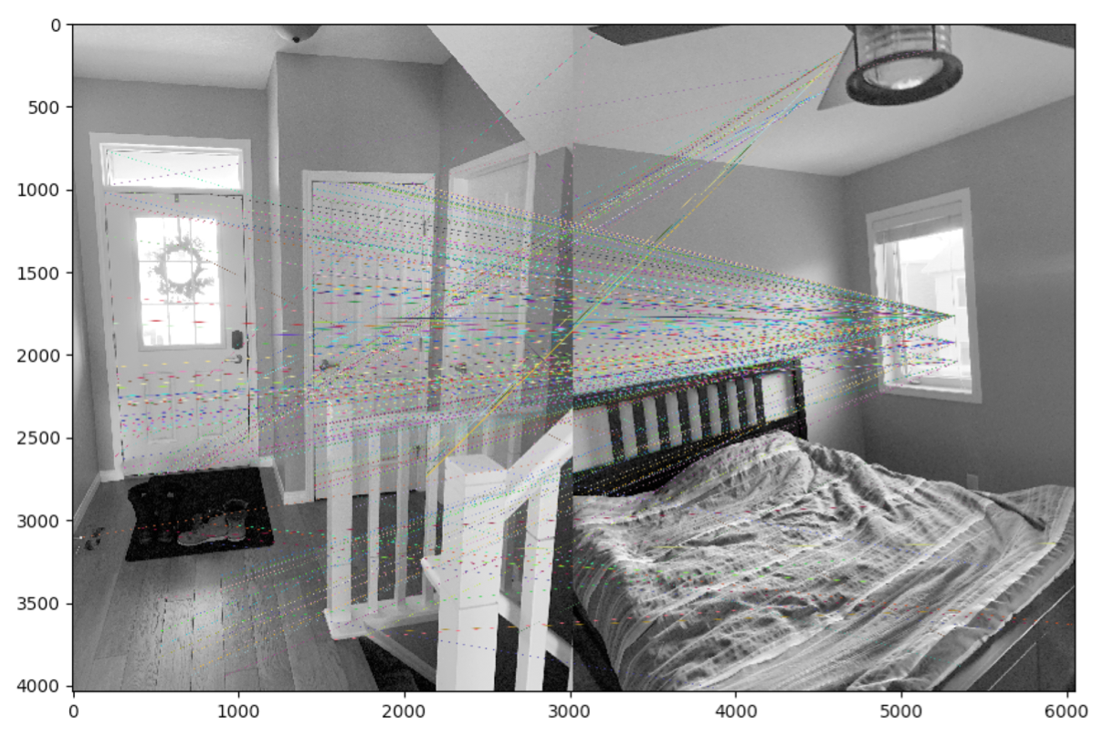

Figure 8: Image matching with noise information

Thirdly, in SIFT algorithm, the key point is selected by comparing the pixel and the pixels around it in the scale space. Therefore, for the image whose intensity is much skewed, improving the contrast of images could benefit the selection of key points, hence the process of image matching. This is especially used for images that are over-exposed, under-exposed, and those are taken under dark and bright environment.

Fourthly, given the limited size of the environment of experiment, the performance of the experiment is quite acceptable . For larger indoor environments such as malls, railway stations, airports and museums, an optimized algorithm can be used to accelerate the process of image matching. There are some variants of SIFT algorithms that can obtain much a faster speed while sacrificing little performance, such as SURF and PCA-SIFT. SURF achieves the performance acceleration by using a less complicated filter to estimate the Laplacian of Gaussian. PCA-SIFT achieves the performance acceleration by using the primary component to describe the key point instead of the 128 dimensional descriptor.

# Conclusion and future plan

1. Plan experiment in a larger environment

2. Develop a detailed and complete method for indoor positioning

3. Evaluate and compare the performance of different algorithms